POV Player



Blinkinlabs LLC
Revision A 2018/06/05

Introduction
The POV Player is a prototyping tool for developing a persistence of vision artwork.

Specifications:
- Maximum LED count: 500 LEDs
- Outputs: 1
- Typical framerate (output lines per second): 1100
- Maximum POV image size: Maximum ~150kB (500 RGBLEDs x 100frames)
- Maximum SPI output speed: 30MHz
- Input power range: 5-24V
- Image format: 24-bit uncompressed bitmap

It supports the following LED types:
- APA102/SK9822
- MBI6020 (used in dot pixel product)

Absolute Maximum Ratings
The absolute maximum ratings indicated sustained limits beyond which damage to the device may occur.
Parameter | Description | Min | Max | Units
VCC | Input Voltage (J2 connector) | -0.3 | 28 | V
I_{LED} | LED output current (J1 connector) |  | 10 | A

Recommended Operating Conditions
For proper operation, the device should be used within the recommended conditions.
Parameter | Description | Min | Max | Units
VCC | Input Voltage (J2 connector) | 5 | 24 | V
I_{LED} | LED output current (J1 connector) |  | 8 | A
*Note: The POV Player is designed to be powered from whatever power supply is used for the LEDs. For APA102/SK9822 strips, this is usually 5V. For the Dot Pixels (MBI6020), the pixels are powered from AC power, so an external power supply should be used. The 12V supply in the existing control box can be used to power the player.

Quick start guide
- Connect either the SK9822 or Dot Pixels, using the steps listed in the section ‘Connection diagram (Dot Pixels)’ or ‘Connection diagram (SK9822 strip)’.
- If the microSD card is inserted in the player, remove it.
- Power on the unit. By default, it will play back a slow test pattern, cycling up to 500 LEDs through red, green, and blue. Note that the default protocol is MBI6020, so if an SK9822 strip is attached, you will need to follow the instructions in the ‘Status Information’ section to switch to APA102/SK9822 mode.
- Use the instructions in the ‘Status Information’ guide to test adjusting the playback speed and clock speed. Also Try increasing the clock speed until the LEDs no longer update properly- that will show the maximum speed supported by the hardware.
- Once the setup is working with the demo pattern, the next step is to load a POV image. Prepare a microSD card with an image using the steps listed in the section ‘Image preparation’
- Place the microSD card in the controller, and turn the power back on.
- Enjoy the POV effect!

Image Preparation
The POV player can load a single POV image from the microSD card. The image must be formatted as a 24-bit, uncompressed bitmap. The LED count is determined by the image height, and the number of POV frames is determined by the image width. For example, if there are 40 LEDs in the system, an image with height 40 should be used. If a small image should be repeated multiple times along the LED strip, simply create an image with multiple copies arranged in a vertical row.

Here are the steps for exporting a compatible bitmap image from Photoshop:

- Insert the microSD card into the computer.
- Launch photoshop, then load the desired image.
- From the file menu, select ‘Save As’
- On the ‘Save as type’ option, select ‘BMP’
- Change the image name to ‘pov.bmp’, and select the root of the SD card drive (for example E:\ on Windows) as the location to save it. Click ‘Save’
- On the ‘BMP Options’ dialog, make sure the File Format is set to ‘Windows’, the Depth is set to ‘24 Bit’, and no other options are selected. Click ‘OK’
- Eject the microSD card from the computer, and place it in the Player.

Connection diagram (Dot Pixels)
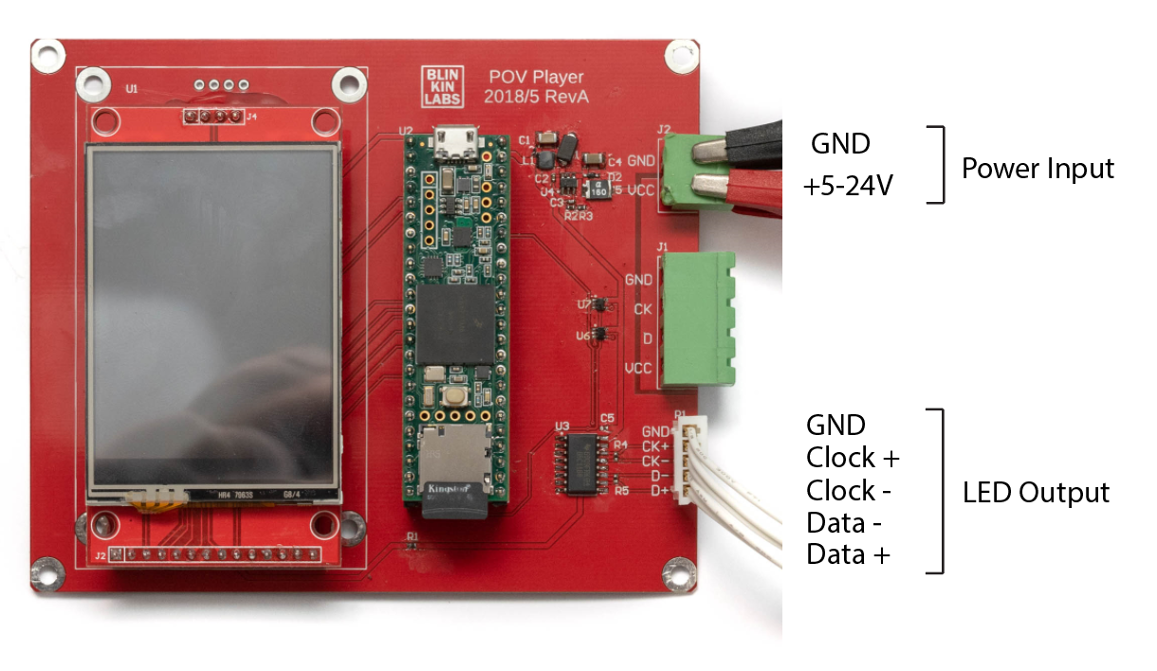
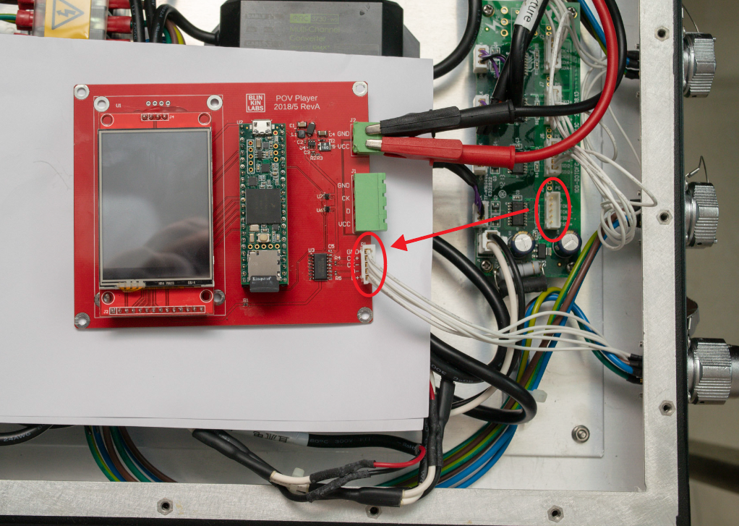

For Dot Pixels, connect a 5-24V power supply to the connector J2. The 12V supply inside the existing metal control box can be used for this. Then, disconnect the white cable from inside the metal control box, and connect it to output P1. Be sure to plug the connector in the right orientation- the pins are labeled on both the original adapter board and the POV Player. In this configuration, the LED power is connected directly to the dot pixel strip, bypassing the POV player.

Note: The P1 connector outputs an RS422 differential signal, suitable for controlling the Dot Pixel samples.

Caution: The Dot Pixels are powered by 220V AC wall power. Be extremely careful when working with this style of pixel, and be sure to mount the POV Player such that none of its electrical connections touch any of the connections in the existing controller box.

Connection diagram (SK9822 strip)
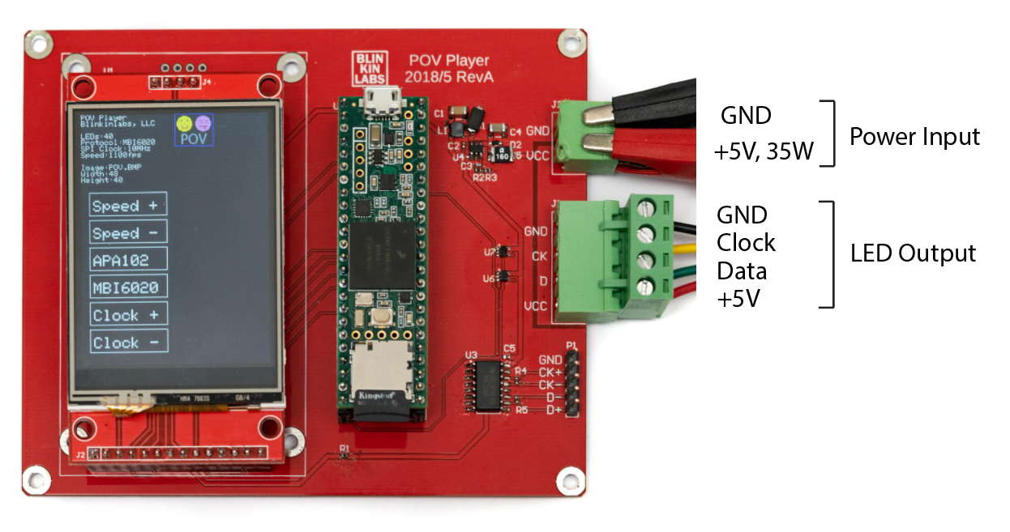
For SK9822 strip, connect a 5V power supply rated at 35W (7A) or greater to the connector J2. Then, connect the SK9822 strip to the connector J2. In this configuration, the LED strip is powered directly from the board, so no further wiring is needed.

Note: The J1 connector outputs a single ended, 5V TTL signal suitable for common LED strips.

Status Interface
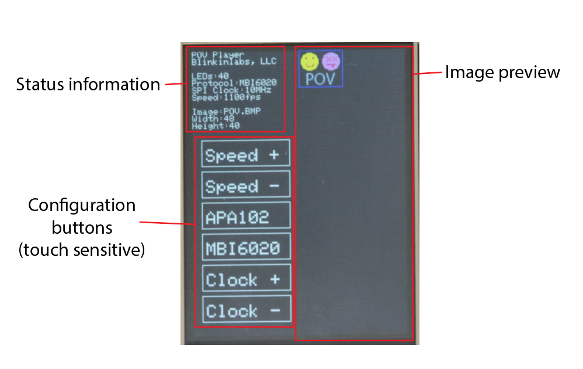

Status Information
The status information section displays the current LED configuration, including LED count, protocol, SPI clock speed, image file name, and image dimensions.

Configuration Buttons
The POV player can be configured by using the on-screen buttons. Simply press a button to change it’s setting.

Button | Description
SPEED + | Increase the POV Speed. If the POV speed is less than 10, it will be incremented by 1 each time the button is pressed. If the POV speed is between 10 and 100, it will be increased by 10 each time the button is pressed. If the POV speed is equal to or greater than 100, it will be incremented by 100 each time the button is pressed.
SPEED - | Decrease the POV Speed. If the POV speed is less than or equal to 10, it will be decremented by 1 each time the button is pressed. If the POV speed is between 11 and 100, it will be decremented by 10 each time the button is pressed. If the POV speed is greater than 100, it will be decremented by 100 each time the button is pressed. The minimum POV speed is 1.
APA102 | Switch the output protocol to APA102/SK9822 mode. Pressing this will also reset the SPI Clock setting to 16MHz.
MBI6020 | Switch the output protocol to MBI6020 mode. Pressing this will also reset the SPI Clock setting to 10MHz. Note that the dot pixels should be connected to the player and powered on before switching to this mode, because the player needs to send configuration information to them before they can be used. Also note that the MBI6020 controllers in the dot pixels can become unresponsive, if data from a different output protocol is sent to them. In that case, turn the AC power off and then on again to reset the dot pixel controllers.
Clock + | Increase the SPI clock speed. The speed will be increased by 1 MHz each time the button is pressed. The maximum workable speed that the player can output depends on the LED type.
Clock - | Decrease the SPI clock speed. The speed will be decreased by 1 MHz each time the button is pressed. The minimum clock speed is 1 MHz.

Image Preview
The image preview shows a color representation of the image that is currently displayed on the screen. If the image is larger than 118x318, only the top-left corner of the image will be shown on the screen, however the full image will still be sent to the pixels.

